MARILYN STAFFORD FOTOREPORTAGE AWARD SUPPORTED BY NIKON

SUBMISSIONS NOW OPEN FOR 2019 PHOTOGRAPHY AWARD

A £2000 prize to showcase positive solutions to global issues through documentary photography is to be awarded to a woman photographer. The international prize will be granted through an award founded by renowned photographer Marilyn Stafford. The international award is free to enter and applicants can be working anywhere across the globe. The prize goes towards the completion of a compelling and cohesive documentary photo essay, which addresses an important social, environmental, economic or cultural issue, whether local or global.

The Marilyn Stafford FotoReportage Award, now in its third year, is facilitated by FotoDocument and is this year supported by Nikon for the first time. Marilyn Stafford (b.1925, USA) honed her own craft under the tutelage of Henri Cartier-Bresson and Robert Capa and is now based in the UK. Stafford was the photographer who shot the now infamous photograph of Albert Einstein at his home in Princetown, New Jersey, in 1948. Her career spanned the 1960s fashion scenes of London and Paris; portraits of significant historical figures such as Sir Richard Attenborough, Edith Piaf, Carlo Levi, Le Corbusier; high profile documentary projects including a reportage on Indira Gandhi as well as extended photo essays on pre-civil war Lebanon and mid-20th century Parisian slums.

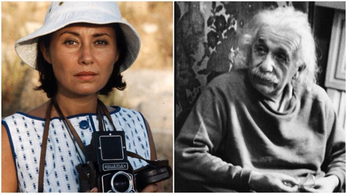
Image: Marilyn Stafford and image of Albert Einstein taken by Marilyn Stafford in 1948.

Women from any stage of their careers can apply for the award, whether emerging, mid-career or established, but they must have completed at least one documentary photo essay to demonstrate a track record. Entrants must be over 18 and they may be any nationality and based anywhere in the world. It is free to submit an application for the award.

The successful work should, in part, showcase positive solutions to any issues it raises in order to contribute to constructive photojournalism, in line with the wishes of Marilyn Stafford and the aims of FotoDocument. The Award is reserved solely for documentary photographers working on projects which are intended to make the world a better place and which may be unreported or under-reported.
Submissions will be reviewed by panel including: Rebecca Conway - 2017 FotoAward winner, Nina Emett - Director of FotoDocument, Rebecca Newton – PR & Social Media Manager Nikon UK and Marilyn Stafford herself among others.

The 2019 FotoAward winner’s work will be screened to an invited audience at the launch of the Marilyn Stafford FotoReportage Award 2020 at the Nikon School London on 10 March next year in celebration of International Women’s Day 2020.

Previous winners have included India-based British photographer Rebecca Conway (2017) whose photo essay, Valley of the Shadow, shines a spotlight on the treatment of civilian trauma (PTSD) in Indian-controlled Kashmir following three decades of conflict and the 2018 winner, Özge Sebzeci, who turned her lens on the marriage of Syrian refugee children in Turkey in her photo essay I Am Beautiful...But My Destiny.

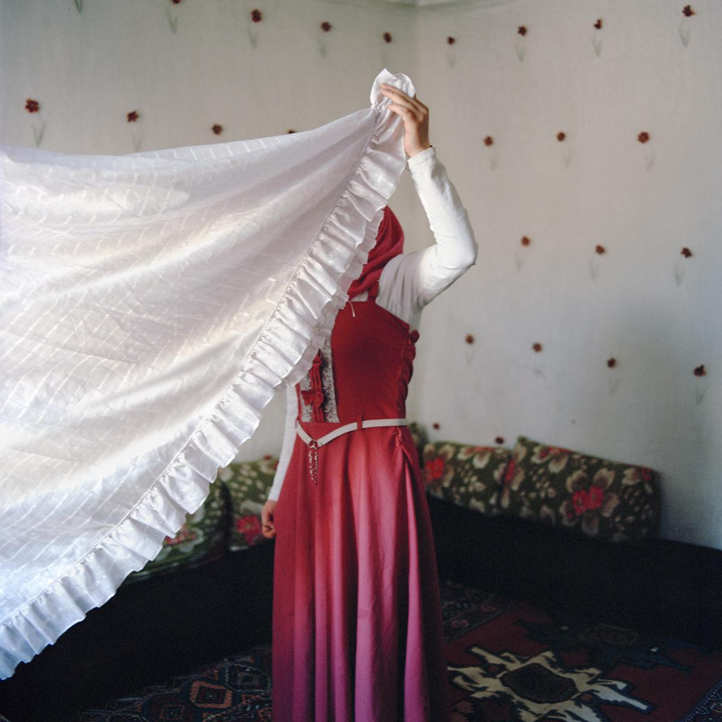
© Özge Sebzeci, winner of 2018 FotoAward

Marilyn Stafford said: “This Award is of great importance to me as there are so many unreported stories out there that need to be told and documentary photography is, in my opinion, the greatest way to do just that. There are now many more women working with cameras and studying photography than when I was working. However, the industry continues to bias towards men in terms of publishing and the issue of equal pay rages on. Instead of getting disheartened, we must just keep striding on to drive change and I hope this Award is one way of doing that.”

Nina Emett, FotoDocument
said: “We are very pleased to be launching the third year of this important photography Award in partnership with our new sponsor, Nikon, in honour of legendary photographer, Marilyn Stafford. We have been overwhelmed with applications from talented women photographers in previous years, which goes to show how much good work is going on behind the scenes, which needs to be given the light of day. With limited publishing opportunities for documentary photographers, even less so for women, we hope to raise the profile of their work both through the grant and through building new relationships with media outlets prioritising a constructive approach to visual story-telling.”

Rebecca Newton, Nikon said: “We are delighted to be sponsoring the Marilyn Stafford FotoReportage Award, which is elevating the incredible work being done by talented female photographers across Europe and the rest of the world. Providing photographers with the equipment to tell their stories is at the heart of what we do. It is an honour to support those who are following in the footsteps of Marilyn Stafford herself to drive real change in the world through inspiring imagery.”

Submissions close on 15 November 2019 and details on how to apply are listed in the notes to editor below.

NOTES TO EDITORS

Media enquiries: Nicola Jeffs nj@nicolajeffs.com / 07794 694754

AWARD TIMELINE:

30 September 2019 Award launches and Call for Submissions opens
15 November 2019 Deadline for photographer submissions
20 November 2019 Receipt of applications acknowledged by FotoDocument
27 November 2019 Shortlist announced
4 December 2019 FotoAward Winner & Honourable Mentions announced
10 March 2020 FotoAward winner’s work screened at launch of Marilyn Stafford FotoReportage Award 2020 at Nikon School London, to celebrate International Women’s Day 2020

Submit via info@fotodocument.org by 5pm on Friday 15 November 2019.

ABOUT MARILYN STAFFORD

Born in Cleveland, Ohio, USA, Marilyn Stafford’s early dreams were for a theatrical career. Her photographic career was accidently launched in New York in 1948 when she was asked to photograph Albert Einstein by friends making a film about him. In the car on the way to Einstein’s home in Princeton, New Jersey, she was given a camera and a quick lesson in how to use it. From there on, her photographic career took her across the world, starting in Paris in the 1950s. There her friendship and guidance by Magnum founders Robert Capa and Henri Cartier-Bresson were instrumental in shaping her work.

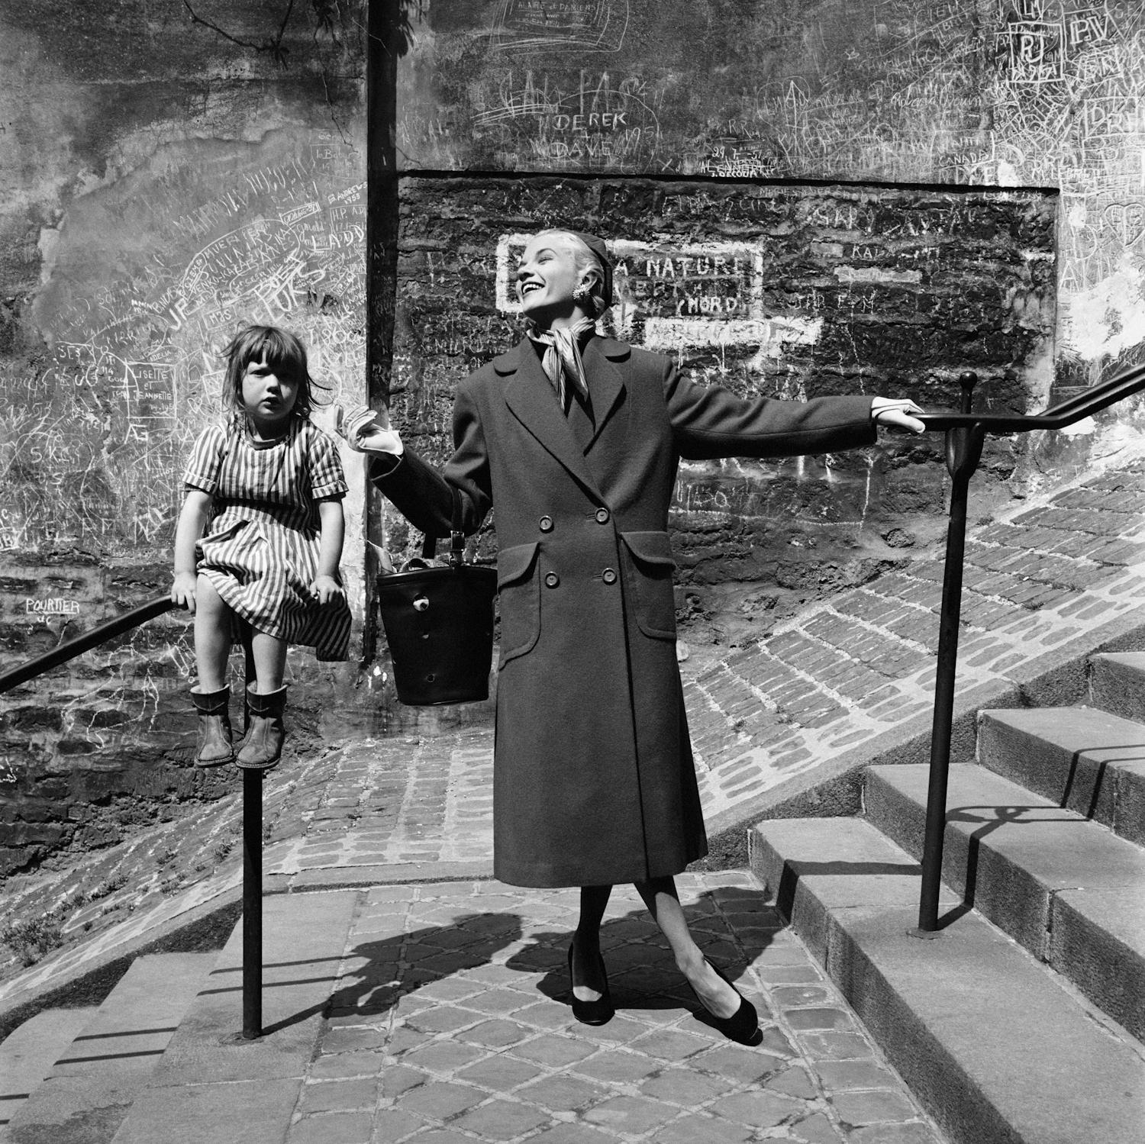
While completing commissions for a number of Paris fashion houses she also photographed children living in one of the city’s worst slums - Cite Lesage-Boullourde – which was later bulldozed to make way for the Paris Opera Bastille, 1984. These photographs are featured in her Monograph: Stories in Pictures - A Photographic Memoir, 1950.

“Some of her Paris work shows the grimy street urchins she liked to befriend… trying to steal the limelight in fashion pictures. One of them, a grumpy little girl in a stripy dress, has been perched unceremoniously on the railings of one of those endless staircases in Montmartre. That one’s not trying to steal anything: she’s just holding on, seemingly forever, while the model emotes over a comically huge reticule […]. You won’t forget that little girl, with her hem hitched above one knee, her squidgy boots, and her curious look of a much older person than she was.” Francis Hodgson, Professor in the Culture of Photography, University of Brighton.

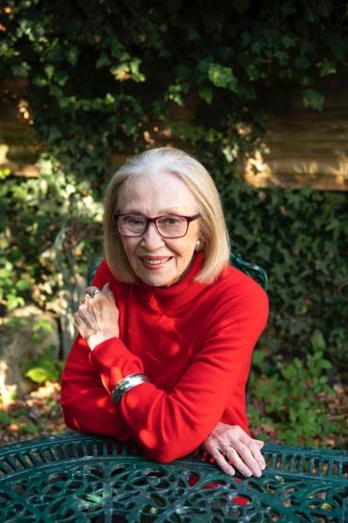
In the early 1960s Stafford travelled widely in Lebanon where she produced the photo book: Silent Stories - A Photographic Journey through Lebanon in the Sixties (Saqi Books, London) and in India where she spent many weeks documenting the country’s only woman Prime Minister, Indira Gandhi.

She settled in England in the mid-sixties, where she was one of only a handful of women photographers working on Fleet Street. Stafford’s work spans from 1948 - 1980 covering a wide range of subjects including refugees, Indian tribal peoples, international fashion and prominent historical figures. Her portraits include Edith Piaf, Lee Marvin, Sir Richard Attenborough, Joanna Lumley, Sir Alan Bates, Italo Calvino among many others. Her work has been exhibited all over the world and is syndicated through Sipa press, Paris and Camera Press, London.

© Nina Emett
Working as a photographer in a largely male industry, Stafford personally experienced how difficult it was for women to balance career and family, especially when each opportunity was hard won. She recognises that this difficulty still exists for women in the industry today, both in terms of pay and opportunity, particularly in the field of documentary photography and photojournalism, and she hopes to help redress the balance with this FotoAward.

www.marilynstaffordphotography.com
@marilynstaffordphotography

ABOUT FOTODOCUMENT

FotoDocument is an award-winning arts organisation, which brings visibility to positive social and environmental initiatives around the world through the medium of documentary photography and mixed media. The work is intended to create a sense of active global citizenship by engaging participants and audiences in powerful social or environmental storylines which affect us all.
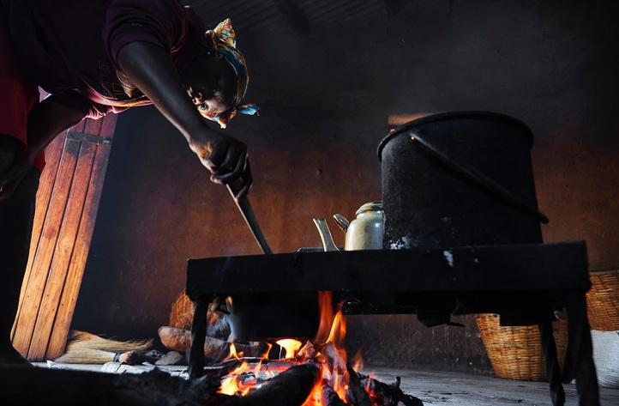
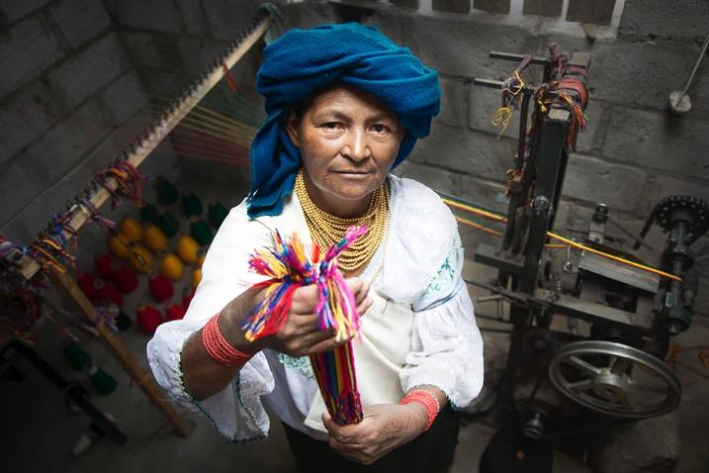

© Ana Caroline de Lima/FotoDocument (left)
© Cynthia Matonhodze/FotoDocument (right)

FotoDocument’s work has been exhibited at a range of venues and events including: Victoria & Albert Museum, House of Commons, Oxo Tower London, London Design Festival, Brighton Railway Station, Hove Promenade, Amex Community Football Stadium. Their commissioned photographers include emerging artists as well as prominent names in photography and they work in partnership with many national organisations and institutions including: Tate Modern Exchange, Photoworks, Counterpoint Arts, London College of Communication, Bioregional. In addition to its project work, FotoDocument creates educational resources and runs bespoke photography workshops through its FotoSchool service, targeted at disadvantaged children and young people in the UK, to break down barriers in arts engagement and create opportunities. Founded as a Social Enterprise, FotoDocument trades through FotoStory, its visual storytelling service for NGOs, corporates and the public sector as well as through its ethical photography service, FotoAgency. In 2015, FotoDocument’s Director, Nina Emett, received a PEA (People, Environment, Achievement) Award for producing and curating a comprehensive environmental arts project, One Planet City, focusing on sustainable living.

fotodocument.org
@fotodocument

PREVIOUS WINNERS OF THE MARILYN STAFFORD FOTOAWARD

2018 FOTOAWARD

The winner of the 2018 FotoAward is Turkish photographer, Özge Sebzeci, for her photo essay: I Am Beautiful – But My Destiny… about the marriage (and sometimes divorce) of underage Syrian refugee children settled within an industrial area of Anatolia.
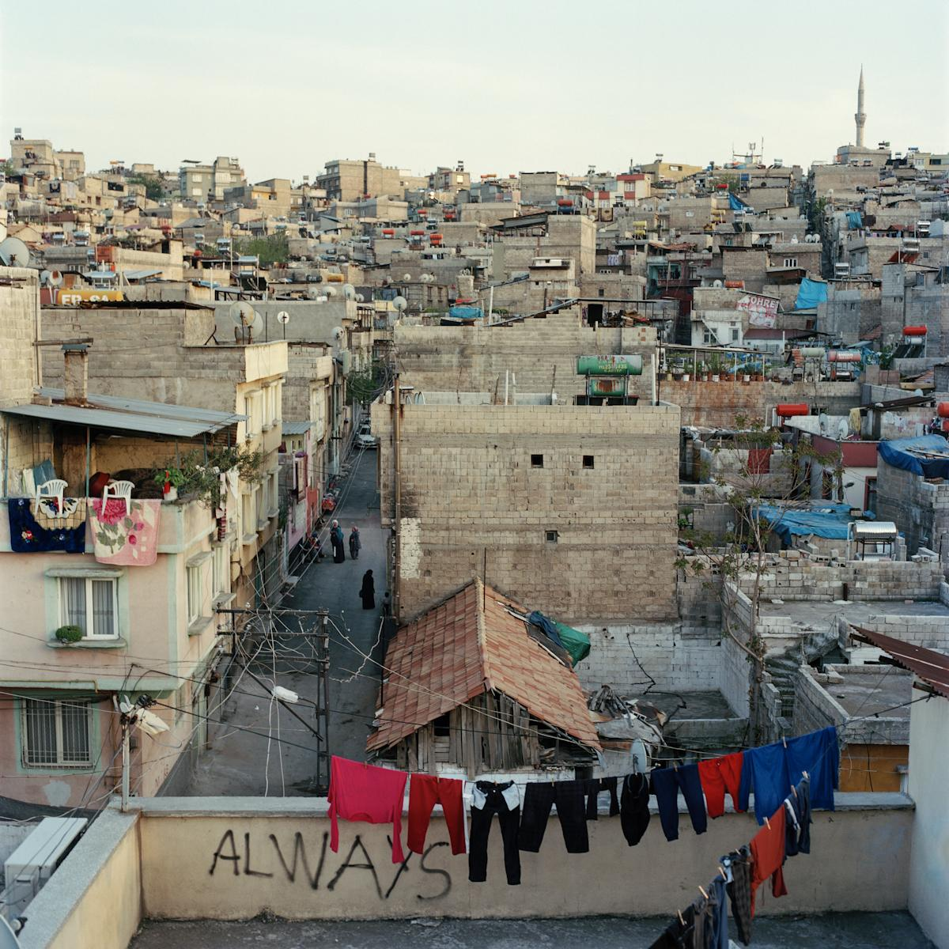

“Winning this award is very important for me in many aspects: it gives me - a freelance photographer from Turkey - the opportunity to dig deeper and cover different aspects of the issue of child marriage among Syrian refugees here and for this under-reported story to be heard by a broader public. Being mentored by the FotoDocument team and Marilyn Stafford has added new perspectives to the story and my development as a storyteller. I am hoping to use this crucial support in the best way I can and bring together a complete work that makes the audience challenge and reflect on.”
Özge Sebzeci

© Özge Sebzeci

2017 FOTOAWARD

The winner of the inaugural 2017 FotoAward is India-based British photographer, Rebecca Conway, for her project: Valley of the Shadow focusing on the treatment of civilian trauma (PTSD) in Indian-controlled Kashmir following three decades of separatist insurgency, conflict and violence.
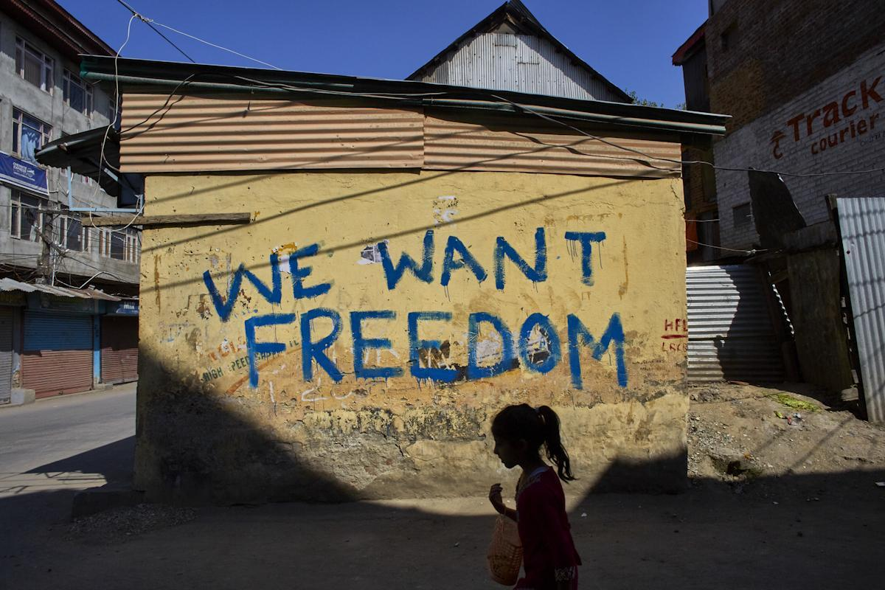

“I'm extremely honoured to be the first recipient of the Marilyn Stafford FotoReportage Award. I've been able to return to Kashmir to keep documenting the stories of those living in the Kashmir Valley, spending time with families affected by the conflict as I build a deeper picture of what living amid continued violence means for Kashmir's civilians. Financially, it means I've been able to afford a translator and driver, making travel in Kashmir safer. It's also encouraging this story has been recognised because the effects of Kashmir's conflict on mental health is rarely reported. I'm also able to show how communities there come together and try to move through what they are experiencing. It's incredible to be recognised by an award in Marilyn’s name given her story.”
Rebecca Conway

© Rebecca Conway

From 30 September, applicants can download an application form from the following link:
https://fotodocument.org/fotoaward/
@fotodocument

DEADLINE: 15 NOVEMBER 2019

